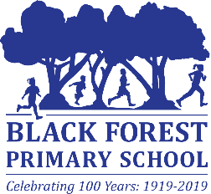
Black Forest Primary School
DHS Online Application – BFPS Initiate Application Only

First Name*
Last Name*
Email*
Date of Birth*
Child’s Name & Room No.*
Reference Number | Office Use Only
Role Description | Various volunteer roles, including excursions, classroom assistance
Screening Required | Working with Children Check
Applicant Type | Volunteer
Application fees to be paid by | Requesting Organisation
Identity Verification – 100 pts

Signature _____________________________ Date __________________

Please Note:
Black Forest Primary School will initiate the application only. Once Sandy has entered the initial data, the applicant is required to activate and complete the online application. Check your email for the link to finish the application

